Introduction
The flowchart provided represents the design and expected course layout of AUT1010, Basics in Automotive Technology. The course is developed to be an introduction to automotive technology, partnered with an internship in the second semester of the program. The course serves the purpose of preparing students for entry level work in automotive technology, and is not intended to be an in-depth or all-inclusive course. Beyond this course and the sequential internship, students may enroll in additional courses that are specific to only one or two of the topics presented here. For example, AUT2020 would be the Advanced Topics in Automotive Tuning, which would focus almost exclusively on the Air and fuel modules of this course. Below are the learning objectives for the course and each module:

Learning Objectives
Course Objectives:
Upon course completion, students will be able to:
- Identify key automotive components and their relative functions
- Examine causes for automotive problems
- Apply knowledge through simulated repairs
- Discuss automotive technology and repair methods with peers and the instructor
- Demonstrate successful completion of all learning simulators related to automotive technology
Module 1 Objectives:
The student will be able to:
- Identify course requirements by completing the syllabus quiz.
- Describe their interest in automotive technology in a 300-word introduction post.
- Discuss their goal and expectations of the course with peers in the introduction forum area.
Module 2 Objectives:
The student will be able to:
- Define and Discuss basic engine functions and theories with their peers.
- Review engine mechanics through text and rich media presentations within the module.
- Analyze basic engine functions and theories by identifying key components in a simulated environment with 80% accuracy or greater.
Module 3 Objectives:
The student will be able to:
- Locate oil systems and components within a simulated environment.
- Explain and discuss oil purposes, types, and systems in class discussion.
- Demonstrate repairs of oil systems in a simulated environment with 80% accuracy or greater.
Module 4 Objectives:
The student will be able to:
- Locate coolant systems and components within a simulated environment.
- Explain and discuss coolant purposes, types, and systems in class discussion.
- Demonstrate repairs of coolant systems in a simulated environment with 80% accuracy or greater.
Module 5 Objectives:
The student will be able to:
- Locate fuel systems and components within a simulated environment.
- Explain and discuss fuel purposes, types, and systems in class discussion.
- Demonstrate repairs of fuel systems in a simulated environment with 80% accuracy or greater.
Module 6 Objectives:
The student will be able to:
- Locate air and exhaust systems and components within a simulated environment.
- Explain and discuss air and exhaust purposes, types, and systems in class discussion.
- Demonstrate repairs of air and exhaust systems in a simulated environment with 80% accuracy or greater.
Module 7 Objectives:
The student will be able to:
- Locate basic electrical systems and components within a simulated environment.
- Explain and discuss basic electrical purposes, types, and systems in class discussion.
- Demonstrate repairs of basic electrical systems in a simulated environment with 80% accuracy or greater.
Module 8 Objectives:
The student will be able to:
- Locate recharging systems and components within a simulated environment.
- Explain and discuss recharging purposes, types, and systems in class discussion.
- Demonstrate repairs of recharging systems in a simulated environment with 80% accuracy or greater.
Module 9 Objectives:
The student will be able to:
- Locate ignition systems and components within a simulated environment.
- Explain and discuss ignition purposes, types, and systems in class discussion.
- Demonstrate repairs of ignition systems in a simulated environment with 80% accuracy or greater.
Module 10 Objectives:
The student will be able to:
- Locate braking systems and components within a simulated environment.
- Explain and discuss braking purposes, types, and systems in class discussion.
- Demonstrate repairs of braking systems in a simulated environment with 80% accuracy or greater.
Module 11 Objectives:
The student will be able to:
- Locate suspension systems and components within a simulated environment.
- Explain and discuss suspension purposes, types, and systems in class discussion.
- Demonstrate repairs of suspension systems in a simulated environment with 80% accuracy or greater.
Module 12 Objectives:
The student will be able to:
- Synthesize all course content by creating a checklist for inspecting a car to be purchased.
- Evaluate their comprehensive knowledge of automotive technology by completing a final simulated activity with 80% accuracy or greater.
- Recall and apply course content for successful completion of a 50-question final exam.

Flowchart
The flowchart begins with the course homepage and progresses through the available menu options. This course will not contain locked modules, allowing students to work ahead and prepare for future modules. Each frame has been given a numerical representation. This numerical value is used for referencing the storyboards beginning on page 13 of this document.

L
M
N
Discussion Post Rubric
0.300
K
Ga
Ba
Ca
Da
J
Course Home
0.100
Rubric
0.210

Storyboard
0.230
MotorTrend
0.240
ASE
0.250
Snap-on
0.270
APTuned
0.280
Syllabus
0.200
ASSURE Model
0.220
Engineering Explained
0.260
H
Fa
Ia
Ea
Aa
Module 12 – 12.000
Module 11 – 11.000
Module 10 – 10.000
Module 9 – 9.000
Module 8 – 8.000
Module 7 – 7.000
Module 6 – 6.000
Module 5 – 5.000
Module 4 – 4.000
Module 3 – 3.000
Module 2 – 2.000
Module 1 – 1.000
Syllabus
0.120
Course Content
0.110
Resources
0.140
Inbox
0.130
Aa
N
M
Additional Resources
1.600
Safety PowerPoint
1.400
Careers in Automotive Technology
1.300
Syllabus Quiz
1.200
Introduction Video
1.100
Discussion
1.500

Ba
How Engines Work
2.300
Engine Types
2.200
N
Additional Resources
2.700
Simulation Activities
2.500
Car Engines Video
2.400
Types of Vehicles
2.100
Discussion
2.600
How Engines Work
2.300
Engine Types
2.200
N
Additional Resources
2.700
Simulation Activities
2.500
Car Engines Video
2.400
Types of Vehicles
2.100
Discussion
2.600
How Engines Work
2.300
Engine Types
2.200
N
Additional Resources
2.700
Simulation Activities
2.500
Car Engines Video
2.400
Types of Vehicles
2.100
Discussion
2.600
Ca
How Engines Work
2.300
Engine Types
2.200
N
Additional Resources
2.700
Simulation Activities
2.500
Car Engines Video
2.400
Types of Vehicles
2.100
Discussion
2.600
Oil Problems
3.300
Oil Types
3.200
N
Additional Resources
3.700
Simulation Activities
3.500
Oil and Lubrication Video
3.400
Oil Systems
3.100
Discussion
3.600
How Engines Work
2.300
Engine Types
2.200
N
Additional Resources
2.700
Simulation Activities
2.500
Car Engines Video
2.400
Types of Vehicles
2.100
Discussion
2.600

Da
Cooling Problems
4.300
Coolant Types
4.200
N
Additional Resources
4.700
Simulation Activities
4.500
Engine Cooling Video
4.400
Coolant Systems
4.100
Discussion
4.600
E
How Engines Work
2.300
Engine Types
2.200
N
Additional Resources
2.700
Simulation Activities
2.500
Car Engines Video
2.400
Types of Vehicles
2.100
Discussion
2.600
Fuel Problems
5.300
Fuel Types
5.200
N
Additional Resources
5.700
Simulation Activities
5.500
Fuel Systems Video
5.400
Fuel Systems
5.100
Discussion
5.600
How Engines Work
2.300
Engine Types
2.200
N
Additional Resources
2.700
Simulation Activities
2.500
Car Engines Video
2.400
Types of Vehicles
2.100
Discussion
2.600

Fa
Additional Resources
6.950
Midterm Quiz
6.900
Discussion
6.800
N
Simulation Activities
6.700
Intake & Exhaust
Video
6.600
Exhaust Problems
6.500
Exhaust Types
6.400
Air Problems
6.300
Air Types
6.200
Air & Exhaust Systems
6.100
Ga
Engine Types
2.200
N
Additional Resources
2.700
Simulation Activities
2.500
Types of Vehicles
2.100
Discussion
2.600
Electrical Safety
7.200
N
Additional Resources
7.800
Simulation Activities
7.500
Electrical Systems
7.100
Discussion
7.600
Engine Types
2.200
N
Additional Resources
2.700
Simulation Activities
2.500
Types of Vehicles
2.100
Discussion
2.600

ECU Video
7.400
Electrical Problems
7.300

Apply for Internship
7.700

Ha
Charging Problems
8.300
Charging Types
8.200
N
Additional Resources
8.700
Simulation Activities
8.500
Charging Systems Video
8.400
Charging Systems
8.100
Discussion
8.600
Ia
How Engines Work
2.300
Engine Types
2.200
N
Additional Resources
2.700
Simulation Activities
2.500
Car Engines Video
2.400
Types of Vehicles
2.100
Discussion
2.600
Ignition Problems
9.300
Ignition Types
9.200
N
Additional Resources
9.700
Simulation Activities
9.500
Ignition Systems Video
9.400
Ignition Systems
9.100
Discussion
9.600
How Engines Work
2.300
Engine Types
2.200
N
Additional Resources
2.700
Simulation Activities
2.500
Car Engines Video
2.400
Types of Vehicles
2.100
Discussion
2.600

Ja
Brake Problems
10.300
Brake Types
10.200
N
Additional Resources
10.700
Simulation Activities
10.500
Brakes Video
10.400
Brake Systems
10.100
Discussion
10.600

Ka
How Engines Work
2.300
Engine Types
2.200
N
Additional Resources
2.700
Simulation Activities
2.500
Car Engines Video
2.400
Types of Vehicles
2.100
Discussion
2.600
Suspension Problems
11.300
N
Additional Resources
11.700
Simulation Activities
11.500
Suspension Explanation Video
11.400
Suspension Systems
11.100
Discussion
11.600
How Engines Work
2.300
Engine Types
2.200
N
Additional Resources
2.700
Simulation Activities
2.500
Car Engines Video
2.400
Types of Vehicles
2.100
Discussion
2.600

Suspension Types
11.200

La
Final Exam
12.300

Confirm Internship
12.400
End of Course Video
12.100
Cumulative Simulation Activities
12.200

Storyboards

The storyboards provided below will be used as a guideline for developing the course modules. Each storyboard frame has an associated frame in the flowchart, identified by their numerical placement. These storyboards are listed in sequence to their numerical value.
Each storyboard contains the Scene, which will indicate where you are in the course. The Slide Number is the correspondence with the flowchart, and the Title is the title of that of section in the course. The On-Screen field is used to provide representations of expected outcomes. The Text area contains course content. The Programming Notes is used to describe functions for each page.

Scene Top Level: Course Home
Scene Home, Slide 0.100
Title: Course Home
On-Screen | Text
Home page will contain a welcome banner, introduction text, and welcome video by the instructor.  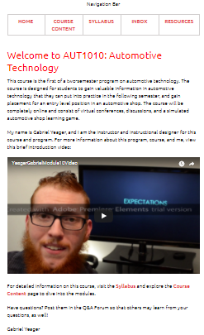 | Welcome to AUT1010: Automotive Technology  This course is the first of a two-semester program on automotive technology. The course is designed for students to gain valuable information in automotive technology that they can put into practice in the following semester, and gain placement for an entry level position in an automotive shop. The course will be completely online and consist of virtual conferences, discussions, and a simulated automotive shop learning game.  My name is Gabriel Yeager, and I am the instructor and instructional designer for this course and program. For more information about this program, course, and me, view this brief introduction video:  For detailed information on this course, visit the Syllabus and explore the Course Content page to dive into the modules.  Have questions? Post them in the Q&A Forum so that others may learn from your questions, as well!  Gabriel Yeager
Programming Notes
Provide navigation bar along the top of the screen. Include links in navigation to Home (current page), Course Content, Syllabus, Inbox, and Resources.
Embed the YouTube welcome video to fit with text width.
Use hyperlinks in the text for the syllabus and course content.

Scene Top Level: Course Content
Scene Top Level, Slide 0.110
Title: Course Content
On-Screen | Text
Banner of Nissan 300ZX presented along the top of the screen.  Display table of contents. | To begin each module, select the topic title in the second column.  Insert table of contents with due dates and objectives from the ASSURE document.
Programming Notes
Provide navigation bar along the top of the screen. Include links in navigation to Home, Course Content (current page), Syllabus, Inbox, and Resources.
In the Topics column, link each topic title to their respective module.

Scene Top Level: Syllabus
Scene Top Level, Slide 0.120
Title: Syllabus
On-Screen | Text
Display banner of Honda S2000.  Provide course syllabus in plain HTML. | Copy/Paste syllabus document in plain HTML.
Programming Notes
Provide navigation bar along the top of the screen. Include links in navigation to Home, Course Content, Syllabus (current page), Inbox, and Resources.

Scene Top Level: Inbox
Scene Top Level, Slide 0.130
Title: Inbox
On-Screen | Text
Display the LMS messaging inbox system. | No additional text needed.
Programming Notes
Provide navigation bar along the top of the screen. Include links in navigation to Home, Course Content, Syllabus, Inbox (current page), and Resources.

Use LMS messaging system.

Scene Top Level: Resources
Scene Top Level, Slide 0.140
Title: Resources
On-Screen | Text
Display Mitsubishi 3000GT banner  Provide text written on side. | AUT1010, Additional Resources  Looking for more information?  Course Design Documents: (download)  - Syllabus (0.200)  - Assessment Rubric (0.210)  - ASSURE Model (0.220  - Storyboard (0.230)  Relevant Sites:  MotorTrend (0.240, external link)  Automotive Service Excellence (0.250, external link)  Engineering Explained (0.260, external link)  Snap-on (0.270, external link)  APTuned (0.280, external link)
Programming Notes
Provide navigation bar along the top of the screen. Include links in navigation to Home, Course Content, Syllabus, Inbox, and Resources (current page).

Provide links to download course design documents.
Provide links to relevant external sites.

Scene Second Level: Syllabus
Scene Second Level, Slide 0.200
Title: Syllabus
On-Screen | Text
When the user clicks on the link to this location, it will download the syllabus file. | No text. This is the syllabus file.
Programming Notes
When the user selects the path to this location, it will download the YeagerGabrielSyllabus.docx file.

Scene Second Level: Rubric
Scene Second Level, Slide 0.210
Title: Rubric
On-Screen | Text
When the user selects this link, it will download the Discussion Post Rubric file. | No Text. This is the Discussion Post Rubric File.
Programming Notes
When the user selects this link, it will download the YeagerGabrielRubric.docx file.

Scene Second Level: ASSURE Model
Scene Second Level, Slide 0.220
Title: ASSURE Model
On-Screen | Text
When the user selects this link, it will download the ASSURE document. | No text. This is the link for downloading the ASSURE document.
Programming Notes
When the user selects this link, download the YeagerGabrielASSURE.docx file.

Scene Second Level: Storyboard
Scene Second Level, Slide 0.230
Title: Storyboard
On-Screen | Text
When the user selects this link, it will download the Storyboard document | No text. This is the link to download the Storyboard document.
Programming Notes
When the user selects this link, download the YeagerGabrielStoryboard.docx file.

Scene Second Level: MotorTrend
Scene Second Level, Slide 0.240
Title: MotorTrend
On-Screen | Text
This is a link to an external site. | No text. This is a link to an external site.
Programming Notes
This is a link to MotorTrend.com

Scene Second Level: ASE
Scene Second Level, Slide 0.250
Title: ASE
On-Screen | Text
This is a link to the ASE website. | No text. This is an external link.
Programming Notes
When users click on this link, take them to ASE.org.

Scene Second Level: Engineering Explained
Scene Second Level, Slide 0.260
Title: Engineering Explained
On-Screen | Text
No text, this is a link to Engineering Explained. | No text, this is a link to Engineering Explained.
Programming Notes
When the user selects this link, take them to youtube.com/engineeringexplained.

Scene Second Level: Snap-on
Scene Second Level, Slide 0.270
Title: Snap-on
On-Screen | Text
This is a link to an external site. | No text, this is a link to an external site.
Programming Notes
When the user selects this link, take them to snap-on.com.

Scene Second Level: APTuned
Scene Second Level, Slide 0.280
Title: APTuned
On-Screen | Text
No content, this is a link to an external site. | No text, this is a link to an external site.
Programming Notes
When the user selects this link, take them to aptuned.com.

Scene Third Level: Discussion Post Rubric
Scene Third Level, Slide 0.300
Title: Discussion Post Rubric
On-Screen | Text
Display Discussion Post Rubric | Display the Discussion Post Rubric, no additional content needed.
Programming Notes
Provide navigation bar along the top of the screen. Include links in navigation to Home, Course Content, Syllabus, Inbox, and Resources.

Scene Module 1: Overview
Scene Module 1, Slide 1.000
Title: Module 1: Overview
On-Screen | Text
To be developed | To be developed
Programming Notes
Provide navigation bar along the top of the screen. Include links in navigation to Home, Course Content, Syllabus, Inbox, and Resources.

To be developed.
Scene Module 1: Introduction Video
Scene Module 1, Slide 1.100
Title: Introduction Video
On-Screen | Text
[Media description or file reference  and screen text]  To be developed. | [Voiceover text or file reference]  To be developed.
Programming Notes
Provide navigation bar along the top of the screen. Include links in navigation to Home, Course Content, Syllabus, Inbox, and Resources.

To be developed.

Scene Module 1: Syllabus Quiz
Scene Module 1, Slide 1.200
Title: Syllabus Quiz
On-Screen | Text
[Media description or file reference  and screen text]  TBD | [Voiceover text or file reference  TBD]
Programming Notes
Provide navigation bar along the top of the screen. Include links in navigation to Home, Course Content, Syllabus, Inbox, and Resources.

TBD

Scene Module 1: Careers in Automotive Technology
Scene Module 1, Slide 1.300
Title: Careers in Automotive Technology
On-Screen | Text
[Media description or file reference  and screen text]  TBD | [Voiceover text or file reference]  TBD
Programming Notes
Provide navigation bar along the top of the screen. Include links in navigation to Home, Course Content, Syllabus, Inbox, and Resources.

TBD

Scene Module 1: Safety PowerPoint
Scene Module 1, Slide 1.400
Title: Safety PowerPoint
On-Screen | Text
[Media description or file reference  and screen text]  Display autorunning Safety PowerPoint file with voice overlay. | [Voiceover text or file reference]  TBD
Programming Notes
Provide navigation bar along the top of the screen. Include links in navigation to Home, Course Content, Syllabus, Inbox, and Resources.

Embed Safety PowerPoint file and set to auto play.

Scene Module 1: Discussion
Scene Module 1, Slide 1.500
Title: Discussion
On-Screen | Text
[Media description or file reference  and screen text]  TBD | [Voiceover text or file reference]  TBD
Programming Notes
Provide navigation bar along the top of the screen. Include links in navigation to Home, Course Content, Syllabus, Inbox, and Resources.

TBD

Scene Module 1: Additional Resources
Scene Module 1, Slide 1.600
Title: Additional Resources
On-Screen | Text
[Media description or file reference  and screen text]  TBD | [Voiceover text or file reference]  TBD
Programming Notes
Provide navigation bar along the top of the screen. Include links in navigation to Home, Course Content, Syllabus, Inbox, and Resources.
TBD

Scene Module 2: Module 2 Overview
Scene Module 2, Slide 2.000
Title: Module 2 Overview
On-Screen | Text
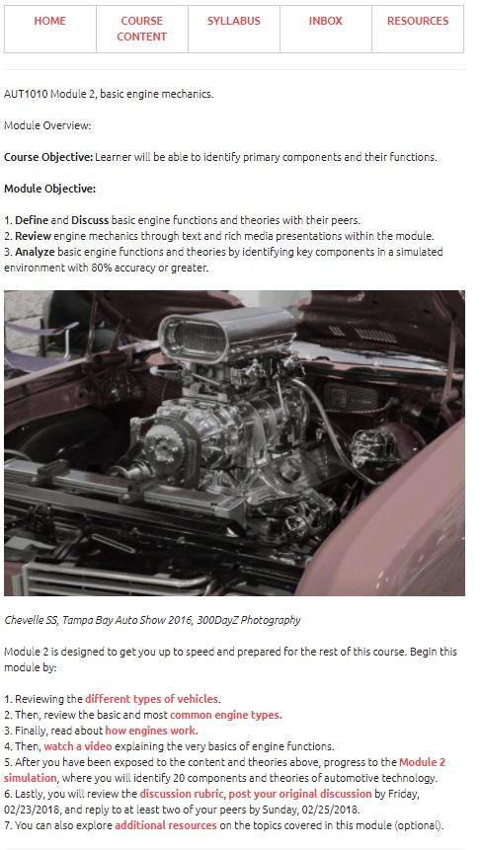 | Module Overview:  Course Objective: Learner will be able to identify primary components and their functions.  Module Objective:  Define and Discuss basic engine functions and theories with their peers.  Review engine mechanics through text and rich media presentations within the module.  Analyze basic engine functions and theories by identifying key components in a simulated environment with 80% accuracy or greater.  DSC_0856 (2).JPG  Chevelle SS, Tampa Bay Auto Show 2016, 300DayZ Photography  Module 2 is designed to get you up to speed and prepared for the rest of this course. Begin this module by:  Reviewing the different types of vehicles.  Then, review the basic and most common engine types.  Finally, read about how engines work.  Then, watch a video explaining the very basics of engine functions.  After you have been exposed to the content and theories above, progress to the Module 2 simulation, where you will identify 20 components and theories of automotive technology.  Lastly, you will review the discussion rubric, post your original discussion by Friday, 02/23/2018, and reply to at least two of your peers by Sunday, 02/25/2018.  You can also explore additional resources on the topics covered in this module (optional).
Programming Notes
Provide navigation bar along the top of the screen. Include links in navigation to Home, Course Content, Syllabus, Inbox, and Resources.
Use Chevelle SS Banner

Embed Chevelle SS image in the middle of text.
Link “different types of vehicles” to 2.100.
Link “common engine types” to 2.200.
Link how engines work to 2.300.
Link “watch a video” to 2.400.
Link “Module 2 Simulation” to 2.500.
Link “discussion rubric” to 0.300.
Link “post your original discussion” to 2.600.
Link “additional resources” to 2.700.

Scene Module 2: Types of Vehicles
Scene Module 2, Slide 2.100
Title: Types of Vehicles
On-Screen | Text
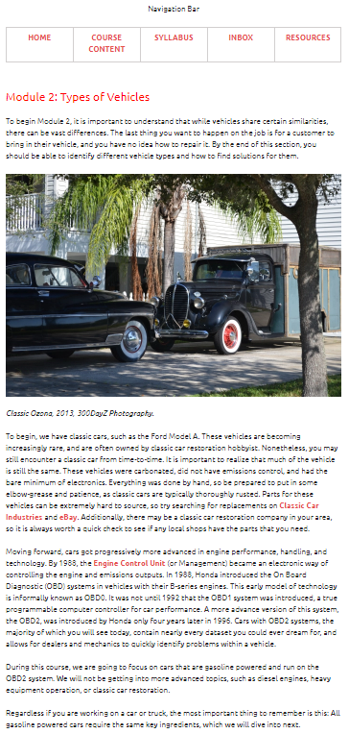 | Module 2: Types of Vehicles  To begin Module 2, it is important to understand that while vehicles share certain similarities, there can be vast differences. The last thing you want to happen on the job is for a customer to bring in their vehicle, and you have no idea how to repair it. By the end of this section, you should be able to identify different vehicle types and how to find solutions for them.  DSC_0101  Classic Ozona, 2013, 300DayZ Photography.  To begin, we have classic cars, such as the Ford Model A. These vehicles are becoming increasingly rare, and are often owned by classic car restoration hobbyist. Nonetheless, you may still encounter a classic car from time-to-time. It is important to realize that much of the vehicle is still the same. These vehicles were carbonated, did not have emissions control, and had the bare minimum of electronics. Everything was done by hand, so be prepared to put in some elbow-grease and patience, as classic cars are typically thoroughly rusted. Parts for these vehicles can be extremely hard to source, so try searching for replacements on Classic Car Industries and eBay. Additionally, there may be a classic car restoration company in your area, so it is always worth a quick check to see if any local shops have the parts that you need.  Moving forward, cars got progressively more advanced in engine performance, handling, and technology. By 1988, the Engine Control Unit (or Management) became an electronic way of controlling the engine and emissions outputs. In 1988, Honda introduced the On Board Diagnostic (OBD) systems in vehicles with their B-series engines. This early model of technology is informally known as OBD0. It was not until 1992 that the OBD1 system was introduced, a true programmable computer controller for car performance. A more advance version of this system, the OBD2, was introduced by Honda only four years later in 1996. Cars with OBD2 systems, the majority of which you will see today, contain nearly every dataset you could ever dream for, and allows for dealers and mechanics to quickly identify problems within a vehicle.  During this course, we are going to focus on cars that are gasoline powered and run on the OBD2 system. We will not be getting into more advanced topics, such as diesel engines, heavy equipment operation, or classic car restoration.  Regardless if you are working on a car or truck, the most important thing to remember is this: All gasoline powered cars require the same key ingredients, which we will dive into next.
Programming Notes
Provide navigation bar along the top of the screen. Include links in navigation to Home, Course Content, Syllabus, Inbox, and Resources.
Use Chevelle SS Banner

Embed Classic Ozona image after first paragraph.
Link “Classic Car Industries” to classicindustries.com.
Link “eBay” to eBay.com.
Link “Engine control Unit” to https://en.wikipedia.org/wiki/Engine_control_unit.

Scene Module 2: Engine Types
Scene Module 2, Slide 2.200
Title: Engine Types
On-Screen | Text
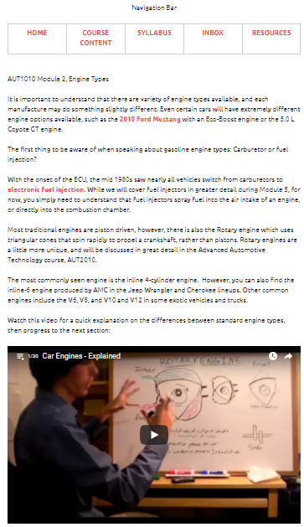 | It is important to understand that there are variety of engine types available, and each manufacture may do something slightly different. Even certain cars will have extremely different engine options available, such as the 2018 Ford Mustang with an Eco-Boost engine or the 5.0 L Coyote GT engine.  The first thing to be aware of when speaking about gasoline engine types: Carburetor or fuel injection?  With the onset of the ECU, the mid 1980s saw nearly all vehicles switch from carburetors to electronic fuel injection. While we will cover fuel injectors in greater detail during Module 5, for now, you simply need to understand that fuel injectors spray fuel into the air intake of an engine, or directly into the combustion chamber.  Most traditional engines are piston driven, however, there is also the Rotary engine which uses triangular cones that spin rapidly to propel a crankshaft, rather than pistons. Rotary engines are a little more unique, and will be discussed in great detail in the Advanced Automotive Technology course, AUT2010.  The most commonly seen engine is the inline 4-cylinder engine. However, you can also find the inline-6 engine produced by AMC in the Jeep Wrangler and Cherokee lineups. Other common engines include the V6, V8, and V10 and V12 in some exotic vehicles and trucks.  Watch this video for a quick explanation on the differences between standard engine types, then progress to the next section:
Programming Notes
Provide navigation bar along the top of the screen. Include links in navigation to Home, Course Content, Syllabus, Inbox, and Resources.
Use Chevelle SS Banner
Link “2018 Ford Mustang” to Ford.com.
Link “electronic fuel injection” to https://en.wikipedia.org/wiki/Fuel_injection.
Embed this YouTube video at the end: https://www.youtube.com/watch?list=PL30C950600B683799&v=1p91gmhlPNo

Scene Module 2: How Engines Work
Scene Module 2, Slide 2.300
Title: How Engines Work
On-Screen | Text
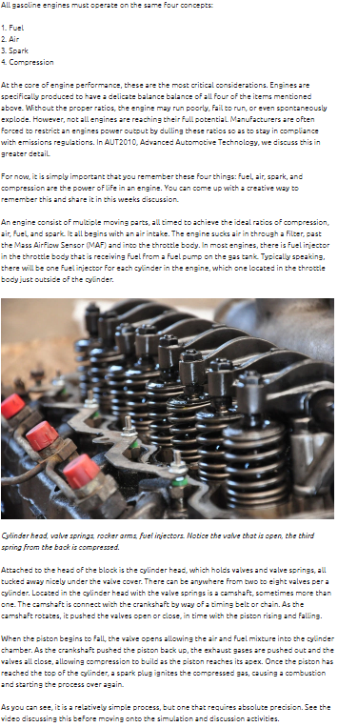 | All gasoline engines must operate on the same four concepts:  Fuel  Air  Spark  Compression  At the core of engine performance, these are the most critical considerations. Engines are specifically produced to have a delicate balance balance of all four of the items mentioned above. Without the proper ratios, the engine may run poorly, fail to run, or even spontaneously explode. However, not all engines are reaching their full potential. Manufacturers are often forced to restrict an engines power output by dulling these ratios so as to stay in compliance with emissions regulations. In AUT2010, Advanced Automotive Technology, we discuss this in greater detail.  For now, it is simply important that you remember these four things: fuel, air, spark, and compression are the power of life in an engine. You can come up with a creative way to remember this and share it in this weeks discussion.  An engine consist of multiple moving parts, all timed to achieve the ideal ratios of compression, air, fuel, and spark. It all begins with an air intake. The engine sucks air in through a filter, past the Mass Airflow Sensor (MAF) and into the throttle body. In most engines, there is fuel injector in the throttle body that is receiving fuel from a fuel pump on the gas tank. Typically speaking, there will be one fuel injector for each cylinder in the engine, which one located in the throttle body just outside of the cylinder.  mechanics-424130_1920  Cylinder head, valve springs, rocker arms, fuel injectors. Notice the valve that is open, the third spring from the back is compressed.  Attached to the head of the block is the cylinder head, which holds valves and valve springs, all tucked away nicely under the valve cover. There can be anywhere from two to eight valves per a cylinder. Located in the cylinder head with the valve springs is a camshaft, sometimes more than one. The camshaft is connect with the crankshaft by way of a timing belt or chain. As the camshaft rotates, it pushed the valves open or close, in time with the piston rising and falling.  When the piston begins to fall, the valve opens allowing the air and fuel mixture into the cylinder chamber. As the crankshaft pushed the piston back up, the exhaust gases are pushed out and the valves all close, allowing compression to build as the piston reaches its apex. Once the piston has reached the top of the cylinder, a spark plug ignites the compressed gas, causing a combustion and starting the process over again.  As you can see, it is a relatively simple process, but one that requires absolute precision. See the video discussing this before moving onto the simulation and discussion activities.
Programming Notes
Provide navigation bar along the top of the screen. Include links in navigation to Home, Course Content, Syllabus, Inbox, and Resources.
Use Chevelle SS Banner.
Embed Cylinder Head image after third full paragraph.

Scene Module 2: Car Engines Video
Scene Module 2, Slide 2.400
Title: Video: Car Engines Explained
On-Screen | Text
This a link to an external site. | This a link to an external site.
Programming Notes
When the user selects this link, take them to: https://www.youtube.com/watch?v=1p91gmhlPNo&list=PL30C950600B683799

Scene Module 2: Simulation Activities
Scene Module 2, Slide 2.500
Title: Simulation Activities
On-Screen | Text
Embed simulation activity for Module 2. | Simulation activity to be created.
Programming Notes
Provide navigation bar along the top of the screen. Include links in navigation to Home, Course Content, Syllabus, Inbox, and Resources.
Use Chevelle SS Banner.
Embed Module 2 Simulation Activity in page.

Scene Module 2: Discussion
Scene Module 2, Slide 2.600
Title: Discussion
On-Screen | Text
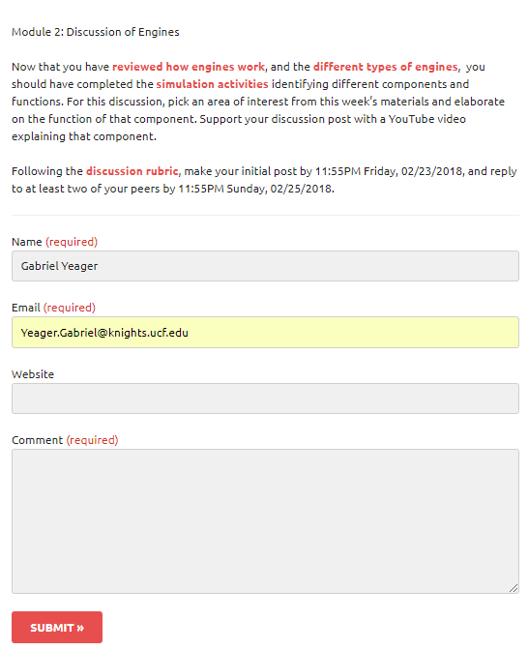 | Module 2: Discussion of Engines  Now that you have reviewed how engines work, and the different types of engines, you should have completed the simulation activities identifying different components and functions. For this discussion, pick an area of interest from this week’s materials and elaborate on the function of that component. Support your discussion post with a YouTube video explaining that component.  Following the discussion rubric, make your initial post by 11:55PM Friday, 02/23/2018, and reply to at least two of your peers by 11:55PM Sunday, 02/25/2018.
Programming Notes
Provide navigation bar along the top of the screen. Include links in navigation to Home, Course Content, Syllabus, Inbox, and Resources.
Use Chevelle SS Banner.
Link “reviewed how engines work” to 2.300.
Link “different types of engines” to 2.200.
Link “simulation activities” to 2.500.
Link “discussion rubric” to 0.300.
Use LMS discussion tool to create this area.

Scene Module 2: Additional Resources
Scene Module 2, Slide 2.700
Title: Additional Resources
On-Screen | Text
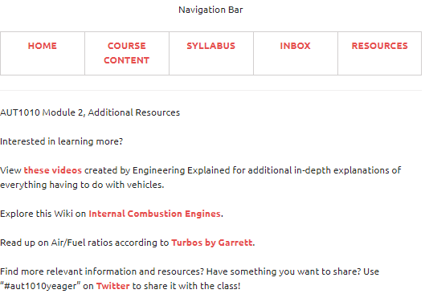 | AUT1010 Module 2, Additional Resources  Interested in learning more?  View these videos created by Engineering Explained for additional in-depth explanations of everything having to do with vehicles.  Explore this Wiki on Internal Combustion Engines.  Read up on Air/Fuel ratios according to Turbos by Garrett.  Find more relevant information and resources? Have something you want to share? Use “#aut1010yeager” on Twitter to share it with the class!
Programming Notes
Provide navigation bar along the top of the screen. Include links in navigation to Home, Course Content, Syllabus, Inbox, and Resources.
Use Chevelle SS Banner.
Link “these videos” to https://youtu.be/8Rsl8jzlgno
Link “Internal Combustion Engines” to https://en.wikipedia.org/wiki/Internal_combustion_engine
Link “Turbos by Garrett” to https://www.turbobygarrett.com/turbobygarrett/airfuel_ratio_tuning_rich_vs_lean
Link “Twitter” to http://twitter.com/

Scene Module 3: Module 3 Overview
Scene Module 3, Slide 3.000
Title: Module 3: Overview
On-Screen | Text
[Media description or file reference  and screen text]  TBD | [Voiceover text or file reference]  TBD
Programming Notes
[Description of image or button placement, interactions, branching, etc.]

TBD

Scene Module 3: Oil Systems
Scene Module 3, Slide 3.100
Title: Oil Systems
On-Screen | Text
[Media description or file reference  and screen text]  TBD | [Voiceover text or file reference]  TBD
Programming Notes
[Description of image or button placement, interactions, branching, etc.]

TBD

Scene Module 3: Oil Types
Scene Module 3, Slide 3.200
Title: Oil Types
On-Screen | Text
[Media description or file reference  and screen text]  TBD | [Voiceover text or file reference]  TBD
Programming Notes
[Description of image or button placement, interactions, branching, etc.]
TBD

Scene Module 3: Oil Problems
Scene Module 3, Slide 3.300
Title: Oil Problems
On-Screen | Text
[Media description or file reference  and screen text]  TBD | [Voiceover text or file reference]  TBD
Programming Notes
[Description of image or button placement, interactions, branching, etc.]
TBD

Scene Module 3: Oil and Lubrication Video
Scene Module 3, Slide 3.400
Title: Oil and Lubrication Video
On-Screen | Text
This is a link to an external video | This a link to an external video.
Programming Notes
When this link is selected, redirect user to: https://www.youtube.com/watch?v=tYkg0oDUXs8

Scene Module 3: Simulation Activities
Scene Module 3, Slide 3.500
Title: Simulation Activities
On-Screen | Text
Embed Module 3 simulation activity. | No additional text.
Programming Notes
Embed module 3 simulation activity.

Scene Module 3: Discussion
Scene Module 3, Slide 3.600
Title: Discussion
On-Screen | Text
[Media description or file reference  and screen text]  TBD | [Voiceover text or file reference]  TBD
Programming Notes
[Description of image or button placement, interactions, branching, etc.]
TBD

Scene Module 3: Additional Resources
Scene Module 3, Slide 3.700
Title: Additional Resources
On-Screen | Text
[Media description or file reference  and screen text]  TBD | [Voiceover text or file reference]  TBD
Programming Notes
[Description of image or button placement, interactions, branching, etc.]
TBD

Scene Module 4: Module 4 Overview
Scene Module 4, Slide 4.000
Title: Module 4: Overview
On-Screen | Text
[Media description or file reference  and screen text]  TBD | [Voiceover text or file reference]  TBD
Programming Notes
[Description of image or button placement, interactions, branching, etc.]
TBD

Scene Module 4: Coolant Systems
Scene Module 4, Slide 4.100
Title: Coolant Systems
On-Screen | Text
[Media description or file reference  and screen text]  TBD | [Voiceover text or file reference]  TBD
Programming Notes
[Description of image or button placement, interactions, branching, etc.]
TBD

Scene Module 4: Coolant Types
Scene Module 4, Slide 4.200
Title: Coolant Types
On-Screen | Text
[Media description or file reference  and screen text]  TBD | [Voiceover text or file reference]  TBD
Programming Notes
[Description of image or button placement, interactions, branching, etc.]
TBD

Scene Module 4: Cooling Problems
Scene Module 4, Slide 4.300
Title: Cooling Problems
On-Screen | Text
[Media description or file reference  and screen text]  TBD | [Voiceover text or file reference]  TBD
Programming Notes
[Description of image or button placement, interactions, branching, etc.]

TBD

Scene Module 4: Engine Cooling Video
Scene Module 4, Slide 4.400
Title: Video: Engine Cooling
On-Screen | Text
Link to external video | This a link to an external video
Programming Notes
When the user selects this link, redirect them to: https://www.youtube.com/watch?v=Q56k37FsRcA

Scene Module 4: Simulation Activities
Scene Module 4, Slide 4.500
Title: Simulation Activities
On-Screen | Text
Embed Module 4 simulation. | No additional text.
Programming Notes
Embed Module 4 Simulation file.

Scene Module 4: Discussion
Scene Module 4, Slide 4.600
Title: Discussion
On-Screen | Text
[Media description or file reference  and screen text]  TBD | [Voiceover text or file reference]  TBD
Programming Notes
[Description of image or button placement, interactions, branching, etc.]
TBD

Scene Module 4: Additional Resources
Scene Module 4, Slide 4.700
Title: Additional Resources
On-Screen | Text
[Media description or file reference  and screen text]  TBD | [Voiceover text or file reference]  TBD
Programming Notes
[Description of image or button placement, interactions, branching, etc.]
TBD

Scene Module 5: Module 5 Overview
Scene Module 5, Slide 5.000
Title: Module 5: Overview
On-Screen | Text
[Media description or file reference  and screen text]  TBD | [Voiceover text or file reference]  TBD
Programming Notes
[Description of image or button placement, interactions, branching, etc.]
TBD

Scene Module 5: Fuel Systems
Scene Module 5, Slide 5.100
Title: Fuel Systems
On-Screen | Text
[Media description or file reference  and screen text]  TBD | [Voiceover text or file reference]  TBD
Programming Notes
[Description of image or button placement, interactions, branching, etc.]
TBD

Scene Module 5: Fuel Types
Scene Module 5, Slide 5.200
Title: Fuel Types
On-Screen | Text
[Media description or file reference  and screen text]  TBD | [Voiceover text or file reference]  TBD
Programming Notes
[Description of image or button placement, interactions, branching, etc.]
TBD

Scene Module 5: Fuel Problems
Scene Module 5, Slide 5.300
Title: Fuel Problems
On-Screen | Text
[Media description or file reference  and screen text]  TBD | [Voiceover text or file reference]  TBD
Programming Notes
[Description of image or button placement, interactions, branching, etc.]
TBD

Scene Module 5: Fuel Systems Video
Scene Module 5, Slide 5.400
Title: Video: Fuel Systems
On-Screen | Text
This is an external video | This is a link to an external video.
Programming Notes
When the user selects this link, redirect them to: https://www.youtube.com/watch?v=nbCe68ck6qg

Scene Module 5: Simulation Activities
Scene Module 5, Slide 5.500
Title: Simulation Activities
On-Screen | Text
Embed module 5 simulation. | No additional text.
Programming Notes
Embed module 5 simulation activity.

Scene Module 5: Discussion
Scene Module 5, Slide 5.600
Title: Discussion
On-Screen | Text
[Media description or file reference  and screen text]  TBD | [Voiceover text or file reference]  TBD
Programming Notes
[Description of image or button placement, interactions, branching, etc.]

TBD

Scene Module 5: Additional Resources
Scene Module 5, Slide 5.700
Title: Additional Resources
On-Screen | Text
[Media description or file reference  and screen text]  TBD | [Voiceover text or file reference]  TBD
Programming Notes
[Description of image or button placement, interactions, branching, etc.]

TBD

Scene Module 6: Module 6 Overview
Scene Module 6, Slide 6.000
Title: Module 6 Overview
On-Screen | Text
[Media description or file reference  and screen text]  TBD | [Voiceover text or file reference]  TBD
Programming Notes
[Description of image or button placement, interactions, branching, etc.]

TBD

Scene Module 6: Air & Exhaust Systems
Scene Module 6, Slide 6.100
Title: Air & Exhaust Systems
On-Screen | Text
[Media description or file reference  and screen text]  TBD | [Voiceover text or file reference]  TBD
Programming Notes
[Description of image or button placement, interactions, branching, etc.]

TBD

Scene Module 6: Air Types
Scene Module 6, Slide 6.200
Title: Air Types
On-Screen | Text
[Media description or file reference  and screen text]  TBD | [Voiceover text or file reference]  TBD
Programming Notes
[Description of image or button placement, interactions, branching, etc.]
TBD

Scene Module 6: Air Problems
Scene Module 6, Slide 6.300
Title: Air Problems
On-Screen | Text
[Media description or file reference  and screen text]  TBD | [Voiceover text or file reference]  TBD
Programming Notes
[Description of image or button placement, interactions, branching, etc.]
TBD

Scene Module 6: Exhaust Types
Scene Module 6, Slide 6.400
Title: Exhaust Types
On-Screen | Text
[Media description or file reference  and screen text]  TBD | [Voiceover text or file reference]  TBD
Programming Notes
[Description of image or button placement, interactions, branching, etc.]

TBD

Scene Module 6: Exhaust Problems
Scene Module 6, Slide 6.500
Title: Exhaust Problems
On-Screen | Text
[Media description or file reference  and screen text]  TBD | [Voiceover text or file reference]  TBD
Programming Notes
[Description of image or button placement, interactions, branching, etc.]
TBD

Scene Module 6: Intake and Exhaust Video
Scene Module 6, Slide 6.600
Title: Intake and Exhaust Video
On-Screen | Text
Embed the Intake video, then embed the Exhaust video. | Now that you have read about these systems, watch these videos on air intakes and exhaust systems:
Programming Notes
Embed this video: https://www.youtube.com/watch?v=FaYIHQGU00k
Then embed this video after it: https://www.youtube.com/watch?v=e72Xkf_5VXo

Scene Module 6: Simulation Activities
Scene Module 6, Slide 6.700
Title: Simulation Activities
On-Screen | Text
Embed the module 6 simulation activity. | No additional text needed.
Programming Notes
Embed the module 6 simulation activity.

Scene Module 6: Discussion
Scene Module 6, Slide 6.800
Title: Discussion
On-Screen | Text
[Media description or file reference  and screen text]  TBD | [Voiceover text or file reference]  TBD
Programming Notes
[Description of image or button placement, interactions, branching, etc.]

TBD

Scene Module 6: Midterm Quiz
Scene Module 6, Slide 6.900
Title: Midterm Quiz
On-Screen | Text
Embed quiz tool and activate timer for 45 minutes upon the user starting the quiz. | This is a 20-question quiz covering all six modules that you have completed so far. There is a 45-minute timer on the quiz once you select start, and you may only take this quiz one time. You must score 80% or greater to be successful for this assessment. You may view your results immediately after completing the quiz.
Programming Notes
Embed Midterm Quiz with 45-minute timer.

Scene Module 6: Additional Resources
Scene Module 6, Slide 6.950
Title: Additional Resources
On-Screen | Text
[Media description or file reference  and screen text]  TBD | [Voiceover text or file reference]  TBD
Programming Notes
[Description of image or button placement, interactions, branching, etc.]
TBD

Scene Module 7: Module 7 Overview
Scene Module 7, Slide 7.000
Title: Module 7 Overview
On-Screen | Text
[Media description or file reference  and screen text]  TBD | [Voiceover text or file reference]  TBD
Programming Notes
[Description of image or button placement, interactions, branching, etc.]

TBD

Scene Module 7: Electrical Systems
Scene Module 7, Slide 7.100
Title: Electrical Systems
On-Screen | Text
[Media description or file reference  and screen text]  TBD | [Voiceover text or file reference]  TBD
Programming Notes
[Description of image or button placement, interactions, branching, etc.]

TBD

Scene Module 7: Electrical Safety
Scene Module 7, Slide 7.200
Title: Electrical Safety
On-Screen | Text
[Media description or file reference  and screen text]  TBD | [Voiceover text or file reference]  TBD
Programming Notes
[Description of image or button placement, interactions, branching, etc.]

TBD

Scene Module 7: Electrical Problems
Scene Module 7, Slide 7.300
Title: Electrical Problems
On-Screen | Text
[Media description or file reference  and screen text]  TBD | [Voiceover text or file reference]  TBD
Programming Notes
[Description of image or button placement, interactions, branching, etc.]

TBD

Scene Module 7: ECU Video
Scene Module 7, Slide 7.400
Title: ECU Video
On-Screen | Text
This is a link to an external video | No additional text needed.
Programming Notes
When the user selects this link, redirect them to: https://www.youtube.com/watch?v=0XUM6Z7kB4I

Scene Module 7: Simulation Activities
Scene Module 7, Slide 7.500
Title: Simulation Activities
On-Screen | Text
Embed Module 7 Simulation Activity. | No additional text needed.
Programming Notes
Embed Module 7 Simulation Activity.

Scene Module 7: Discussion
Scene Module 7, Slide 7.600
Title: Discussion
On-Screen | Text
[Media description or file reference  and screen text]  TBD | [Voiceover text or file reference]  TBD
Programming Notes
[Description of image or button placement, interactions, branching, etc.]

Scene #: Scene Title
Scene #, Slide #
Title: Title of your slide
On-Screen | Text
[Media description or file reference  and screen text] | [Voiceover text or file reference]
Programming Notes
[Description of image or button placement, interactions, branching, etc.]
TBD

Scene Module 7: Apply for Internship
Scene Module 7, Slide 7.700
Title: Apply for Internship
On-Screen | Text
[Media description or file reference  and screen text]  TBD | [Voiceover text or file reference]  TBD
Programming Notes
[Description of image or button placement, interactions, branching, etc.]

TBD

Scene Module 7: Additional Resources
Scene Module 7, Slide 7.800
Title: Additional Resources
On-Screen | Text
[Media description or file reference  and screen text]  TBD | [Voiceover text or file reference]  TBD
Programming Notes
[Description of image or button placement, interactions, branching, etc.]

TBD

Scene Module 8: Module 8 Overview
Scene Module 8, Slide 8.000
Title: Module 8 Overview
On-Screen | Text
[Media description or file reference  and screen text]  TBD | [Voiceover text or file reference]  TBD
Programming Notes
[Description of image or button placement, interactions, branching, etc.]

TBD

Scene Module 8: Charging Systems
Scene Module 8, Slide 8.100
Title: Charging Systems
On-Screen | Text
[Media description or file reference  and screen text]  TBD | [Voiceover text or file reference]  TBD
Programming Notes
[Description of image or button placement, interactions, branching, etc.]

TBD

Scene Module 8: Charging Types
Scene Module 8, Slide 8.200
Title: Charging Types
On-Screen | Text
[Media description or file reference  and screen text]  TBD | [Voiceover text or file reference]  TBD
Programming Notes
[Description of image or button placement, interactions, branching, etc.]

TBD

Scene Module 8: Charging Problems
Scene Module 8, Slide 8.300
Title: Charging Problems
On-Screen | Text
[Media description or file reference  and screen text]  TBD | [Voiceover text or file reference]  TBD
Programming Notes
[Description of image or button placement, interactions, branching, etc.]

TBD

Scene Module 8: Charging Systems Video
Scene Module 8, Slide 8.400
Title: Charging Systems Video
On-Screen | Text
This is a link to an external video. | No additional text needed.
Programming Notes
When the user selects this link, redirect them to: https://www.youtube.com/watch?v=tiKH48EMgKE

Scene Module 8: Simulation Activities
Scene Module 8, Slide 8.500
Title: Simulation Activities
On-Screen | Text
Embed Module 8 Simulation Activity. | No additional text needed.
Programming Notes
Embed module 8 simulation activity.

Scene Module 8: Discussion
Scene Module 8, Slide 8.600
Title: Discussion
On-Screen | Text
[Media description or file reference  and screen text]  TBD | [Voiceover text or file reference]  TBD
Programming Notes
[Description of image or button placement, interactions, branching, etc.]

TBD

Scene Module 8: Additional Resources
Scene Module 8, Slide 8.700
Title: Additional Resources
On-Screen | Text
[Media description or file reference  and screen text]  TBD | [Voiceover text or file reference]  TBD
Programming Notes
[Description of image or button placement, interactions, branching, etc.]

TBD

Scene Module 9: Module 9 Overview
Scene Module 9, Slide 9.000
Title: Module 9 Overview
On-Screen | Text
[Media description or file reference  and screen text]  TBD | [Voiceover text or file reference]  TBD
Programming Notes
[Description of image or button placement, interactions, branching, etc.]

TBD

Scene Module 9: Ignition Systems
Scene Module 9, Slide 9.100
Title: Ignition Systems
On-Screen | Text
[Media description or file reference  and screen text]  TBD | [Voiceover text or file reference]  TBD
Programming Notes
[Description of image or button placement, interactions, branching, etc.]

TBD

Scene Module 9: Ignition Types
Scene Module 9, Slide 9.200
Title: Ignition Types
On-Screen | Text
[Media description or file reference  and screen text]  TBD | [Voiceover text or file reference]  TBD
Programming Notes
[Description of image or button placement, interactions, branching, etc.]

TBD

Scene Module 9: Ignition Problems
Scene Module 9, Slide 9.300
Title: Ignition Problems
On-Screen | Text
[Media description or file reference  and screen text]  TBD | [Voiceover text or file reference]  TBD
Programming Notes
[Description of image or button placement, interactions, branching, etc.]

TBD

Scene Module 9: Ignition Systems Video
Scene Module 9, Slide 9.400
Title: Ignition Systems Video
On-Screen | Text
This an external video | No additional text needed.
Programming Notes
When the user selects this link, redirect them to: https://www.youtube.com/watch?v=1lZqsZq23pU

Scene Module 9: Simulation Activities
Scene Module 9, Slide 9.500
Title: Simulation Activities
On-Screen | Text
[Media description or file reference  and screen text]  TBD | [Voiceover text or file reference]  TBD
Programming Notes
[Description of image or button placement, interactions, branching, etc.]

TBD

Scene Module 9: Discussion
Scene Module 9, Slide 9.600
Title: Discussion
On-Screen | Text
[Media description or file reference  and screen text]  TBD | [Voiceover text or file reference]  TBD
Programming Notes
[Description of image or button placement, interactions, branching, etc.]

TBD

Scene Module 9: Additional Resources
Scene Module 9, Slide 9.700
Title: Additional Resources
On-Screen | Text
[Media description or file reference  and screen text]  TBD | [Voiceover text or file reference]  TBD
Programming Notes
[Description of image or button placement, interactions, branching, etc.]

TBD

Scene Module 10: Module 10 Overview
Scene Module 10, Slide 10.000
Title: Module 10 Overview
On-Screen | Text
[Media description or file reference  and screen text]  TBD | [Voiceover text or file reference]  TBD
Programming Notes
[Description of image or button placement, interactions, branching, etc.]

TBD

Scene Module 10: Brake Systems
Scene Module 10, Slide 10.100
Title: Brake Systems
On-Screen | Text
[Media description or file reference  and screen text]  TBD | [Voiceover text or file reference]  TBD
Programming Notes
[Description of image or button placement, interactions, branching, etc.]

TBD

Scene Module 10: Brake Types
Scene Module 10, Slide 10.200
Title: Brake Types
On-Screen | Text
[Media description or file reference  and screen text]  TBD | [Voiceover text or file reference]  TBD
Programming Notes
[Description of image or button placement, interactions, branching, etc.]

TBD

Scene Module 10: Brake Problems
Scene Module 10, Slide 10.300
Title: Brake Problems
On-Screen | Text
[Media description or file reference  and screen text]  TBD | [Voiceover text or file reference]  TBD
Programming Notes
[Description of image or button placement, interactions, branching, etc.]

TBD

Scene Module 10: Brake Video
Scene Module 10, Slide 10.400
Title: Brake Video
On-Screen | Text
This is an external video | No additional text is needed.
Programming Notes
When the user selects this link, redirect them to: https://www.youtube.com/watch?v=OjrY7G8o99U

Scene Module 10: Simulation Activities
Scene Module 10, Slide 10.500
Title: Simulation Activities
On-Screen | Text
Embed Module 10 Simulation Activity here. | No additional text needed.
Programming Notes
Embed module 10 simulation activity here.

Scene Module 10: Discussion
Scene Module 10, Slide 10.600
Title: Discussion
On-Screen | Text
[Media description or file reference  and screen text]  TBD | [Voiceover text or file reference]  TBD
Programming Notes
[Description of image or button placement, interactions, branching, etc.]

TBD

Scene Module 10: Additional Resources
Scene Module 10, Slide 10.700
Title: Additional Resources
On-Screen | Text
[Media description or file reference  and screen text]  TBD | [Voiceover text or file reference]  TBD
Programming Notes
[Description of image or button placement, interactions, branching, etc.]

TBD

Scene Module 11: Module 11 Overview
Scene Module 11, Slide 11.000
Title: Module 11 Overview
On-Screen | Text
[Media description or file reference  and screen text]  TBD | [Voiceover text or file reference]  TBD
Programming Notes
[Description of image or button placement, interactions, branching, etc.]

TBD

Scene Module 11: Suspension Systems
Scene Module 11, Slide 11.100
Title: Suspension Systems
On-Screen | Text
[Media description or file reference  and screen text]  TBD | [Voiceover text or file reference]  TBD
Programming Notes
[Description of image or button placement, interactions, branching, etc.]

TBD

Scene Module 11: Suspension Types
Scene Module 11, Slide 11.200
Title: Suspension Types
On-Screen | Text
[Media description or file reference  and screen text]  TBD | [Voiceover text or file reference]  TBD
Programming Notes
[Description of image or button placement, interactions, branching, etc.]

TBD

Scene Module 11: Suspension Problems
Scene Module 11, Slide 11.300
Title: Suspension Problems
On-Screen | Text
[Media description or file reference  and screen text]  TBD | [Voiceover text or file reference]  TBD
Programming Notes
[Description of image or button placement, interactions, branching, etc.]

TBD

Scene Module 11: Suspension Video
Scene Module 11, Slide 11.400
Title: Suspension Video
On-Screen | Text
This is an external video. | No additional text is needed.
Programming Notes
When the user selects this link, redirect them to: https://www.youtube.com/watch?v=jOiOO7qloXQ

Scene Module 11: Simulation Activities
Scene Module 11, Slide 11.500
Title: Simulation Activities
On-Screen | Text
Embed Module 11 Simulation Activity. | No additional text required.
Programming Notes
Embed Module 11 Simulation Activity.

Scene Module 11: Discussion
Scene Module 11, Slide 11.600
Title: Discussion
On-Screen | Text
[Media description or file reference  and screen text]  TBD | [Voiceover text or file reference]  TBD
Programming Notes
[Description of image or button placement, interactions, branching, etc.]

TBD

Scene Module 11: Additional Resources
Scene Module 11, Slide 11.700
Title: Additional Resources
On-Screen | Text
[Media description or file reference  and screen text]  TBD | [Voiceover text or file reference]  TBD
Programming Notes
[Description of image or button placement, interactions, branching, etc.]

TBD

Scene Module 12: Module 12 Overview
Scene Module 12, Slide 12.000
Title: Module 12 Overview
On-Screen | Text
[Media description or file reference  and screen text]  TBD | [Voiceover text or file reference]  TBD
Programming Notes
[Description of image or button placement, interactions, branching, etc.]

TBD

Scene Module 12: End of Course Video
Scene Module 12, Slide 12.100
Title: End of Course Video
On-Screen | Text
Embed the End of Course Video created by the instructor here. | No additional text.
Programming Notes
Embed the End of Course Video file here.

Scene Module 12: Cumulative Simulation Activities
Scene Module 12, Slide 12.200
Title: Cumulative Simulation Activities
On-Screen | Text
Embed Cumulative Simulation Activity. | No additional text needed.
Programming Notes
Embed Cumulative Simulation Activity.

Scene Module 12: Final Exam
Scene Module 12, Slide 12.300
Title: Final Exam
On-Screen | Text
Embed Final Exam here. | The final exam consists of 50 multiple-choice questions based on all 12 modules in this course. You will have 75 minutes to complete the exam. You must score 80% or greater to successfully complete this exam.
Programming Notes
Embed Final Exam with 75-minute timer.

Scene Module 12: Confirm Internship
Scene Module 12, Slide 12.400
Title: Confirm Internship
On-Screen | Text
TBD | TBD
Programming Notes
[Description of image or button placement, interactions, branching, etc.]

TBD

